1.

2.

2.

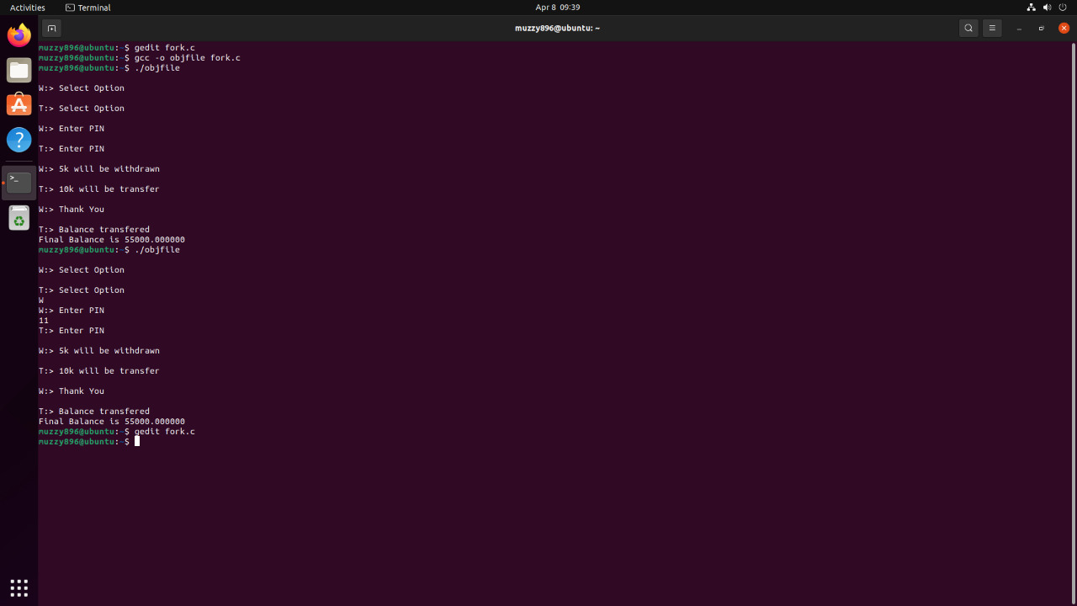

3.

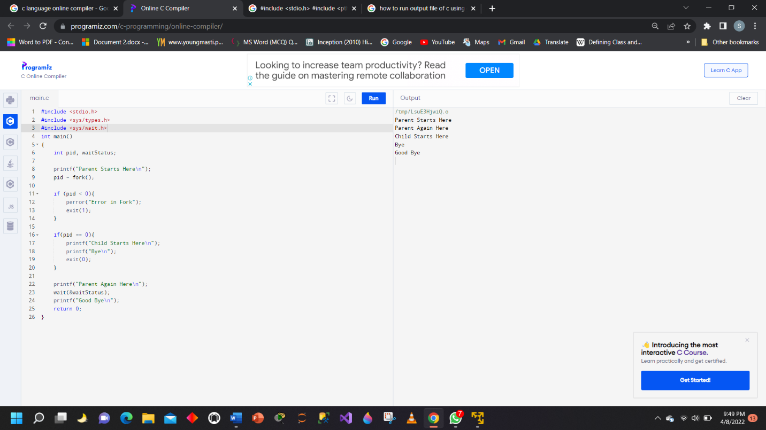

4.

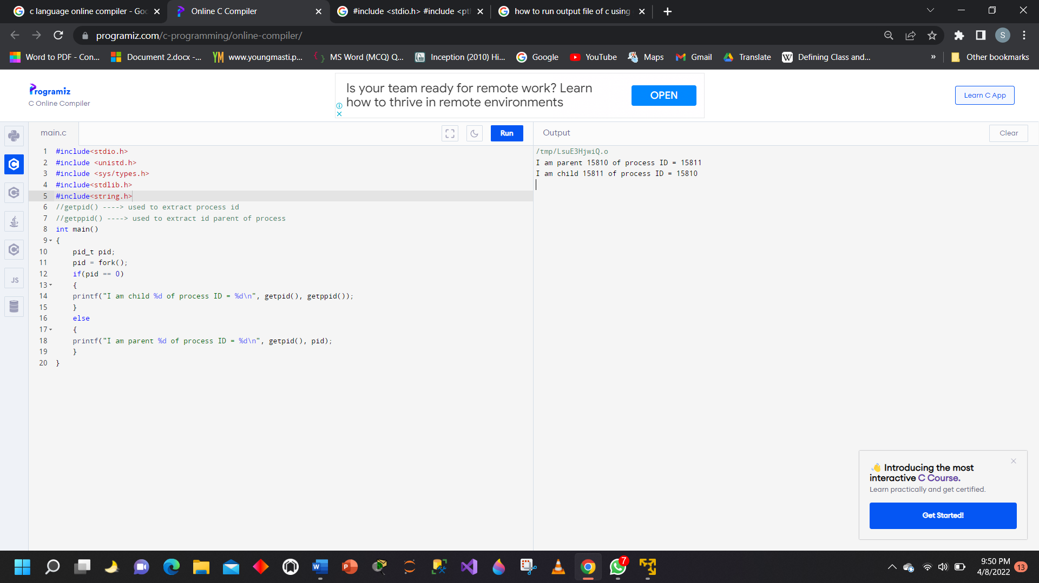

5.

6.

Q6 ANS :-

Child 1 = 25039

a.out  main.c

Child 2 = 25040

global variable is 10, sum is 0

Now I will modify the value of both variables.

updated values within child: global variable is 8, sum is 100

Within Parent: global variable is 10, sum is 0

EXPLANATION

• First made a global variable with value 10 then in Main Function we have pid and sum = 0 ,Then fork called 2 times one for process child 1 and second for process child 2, in parent process it sleeps for just 1 second then wait is called which means the execution will go to the child process first then, print ID of child 1 and execlp is called which overcome the process image.Then Execlp prints the directories of current location. Then Print Child 02 ID, print the value of g_var and sum, print String Line, make sum = 100 and substract 2 from g_var, print values of g_var and sum, it sleeps for 1 sec and then exit child. At last it goes to parent and print values of g_var and sum.